27381

Overview of Virtual Machines

1. Introduction to Virtual Machines
A Virtual Machine (VM) is a software-based emulation of a physical computer. It runs an operating system and applications just like a physical machine. The physical machine that hosts VMs is called the host machine, while the VMs are called guest machines.
VMs are widely used in computing for server consolidation, software development, testing, and cloud computing. They provide flexibility, isolation, and cost-efficiency, making them vital in both academic and commercial IT environments.

2. How Virtual Machines Work
VMs operate through a software layer called a hypervisor. The hypervisor sits between the hardware and the VMs and manages the system's processor, memory, and other resources. It ensures each VM gets what it needs without interfering with others.
There are two main types of hypervisors:
- Type 1 (Bare-metal hypervisors): Installed directly on hardware (e.g., VMware ESXi, Microsoft Hyper-V, Xen).
- Type 2 (Hosted hypervisors): Run on a host operating system (e.g., VMware Workstation, Oracle VirtualBox).
A virtual machine consists of:
- Virtual CPU
- Virtual RAM
- Virtual Hard Disk
- Virtual Network Interface Card
The VM OS (guest OS) treats these virtual components as real hardware.

3. Types of Virtual Machines

1. System Virtual Machines:
- Fully emulate physical machines.
- Run complete OS and software stacks.
- Examples: VMware, VirtualBox.

2. Process Virtual Machines:
- Designed to run a single application or process.
- Terminate once the application ends.
- Example: Java Virtual Machine (JVM).

4. Uses and Applications of Virtual Machines

- Server Consolidation: Multiple VMs run on one physical server, reducing hardware costs.
- Software Testing and Development: Developers use VMs to test in different environments without affecting the main system.
- Disaster Recovery: VMs can be easily backed up and restored.
- Cloud Computing: Major cloud platforms (e.g., AWS, Azure) use VMs to provide virtualized infrastructure.
- Running Multiple OS: Users can run Windows on a Mac or vice versa using VMs.

5. Advantages of Virtual Machines

- Isolation: VMs are sandboxed from the host, increasing security.
- Flexibility: Easy to clone, move, or delete.
- Cost-Efficiency: Reduces need for physical hardware.
- Testing and Rollback: Snapshots allow reverting to previous states.

6. Disadvantages of Virtual Machines

- Performance Overhead: VMs are slower than physical machines due to virtualization overhead.
- Resource Intensive: Multiple VMs can strain CPU, RAM, and disk.
- Complex Management: Requires skilled administrators for efficient VM management.
- Limited Direct Hardware Access: VMs can't fully leverage GPUs or specialized hardware unless configured explicitly (e.g., passthrough).

7. Virtual Machines vs. Containers
While VMs virtualize hardware, containers virtualize the OS. Containers are lightweight and start faster, but VMs provide stronger isolation and are better for running different operating systems on the same host.
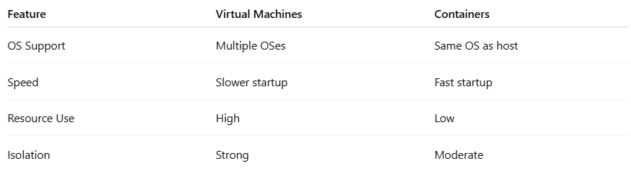

8. Key Virtualization Technologies and Tools

- VMware vSphere: Enterprise-grade virtualization suite.
- Microsoft Hyper-V: Windows-integrated virtualization.
- Oracle VirtualBox: Free and open-source VM solution.
- KVM (Kernel-based Virtual Machine): Linux-native virtualization.
- Proxmox: Open-source virtualization management platform.

9. Future of Virtual Machines
The future of VMs is intertwined with the evolution of cloud computing, edge computing, and hybrid environments. While containers are becoming more popular, VMs remain critical for legacy application support and secure multi-OS operations.

10. Conclusion
Virtual Machines revolutionized computing by enabling efficient, flexible, and secure use of hardware. They are essential in modern IT infrastructure, offering solutions for development, testing, cloud deployment, and more. Despite the rise of newer technologies like containers, VMs continue to be a foundational component of virtualization and cloud ecosystems.

